**terms :**

* spatial resolution
* perceptual grouping - mapping the buildings
* canny edge detection technique
* hough transforms techniques
* bilateral filter
* histogram equalization
* Grayscaling
* Region-Based Segmentation
* Morphological Operations : Fill operation , opening

**code implementation(python):**

* implementation of bilateral filtering
* Real-Time Edge Detection using OpenCV in Python | Canny edge detection method
* histogram equalization - python
* Python | Grayscaling of Images
* Region-Based Segmentation
* Python | Morphological Operations in Image Processing (Opening)

**Hough transform :**

The Hough transform (HT) is a feature extraction approach in image analysis, computer vision, and digital image processing . The HT is a method for separating features of a certain shape inside a picture. The classical HT is most typically employed to detect regular curves such as lines, circles, ellipses, etc. It needs the required features to be provided in some parametric form.

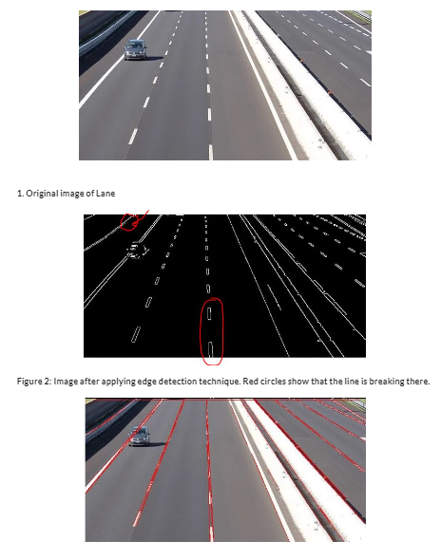

Canny edge deduction:

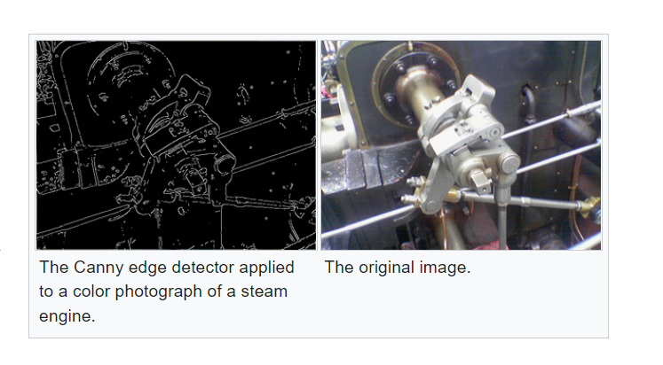

**Bilateral Filtering** : (smoothing noisy image)

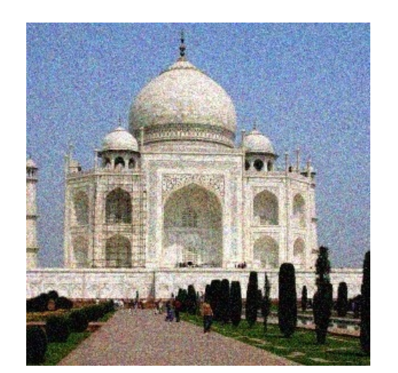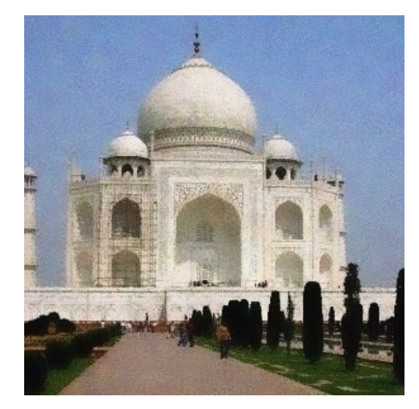

***histogram equalization***

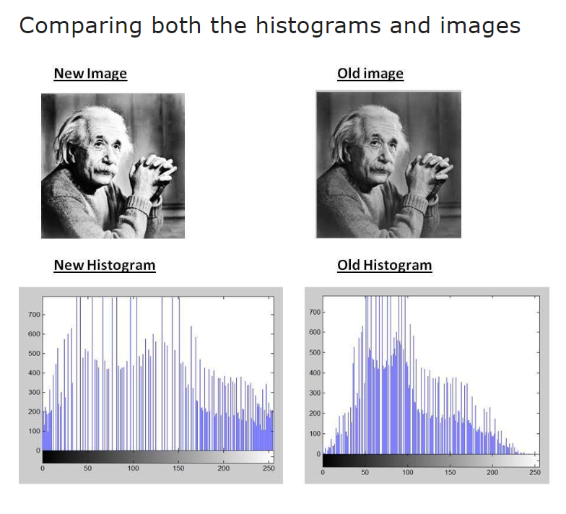

As you can clearly see from the images that the new image contrast has been enhanced and its histogram has also been equalized. There is also one important thing to be note here that during histogram equalization the overall shape of the histogram changes, where as in histogram stretching the overall shape of histogram remains same.

***Block Diagram of Building Detection Proposed System***



**Grayscaling of Images conversion:**

**Grayscaling** is the process of converting an image from other color spaces e.g. RGB, CMYK, HSV, etc. to shades of gray. It varies between complete black and complete white.

 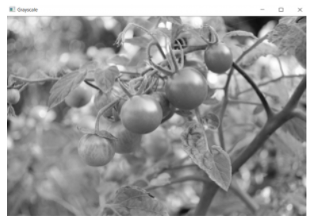

Image Pre-Processing :



## **Image Segmentation**

Image Segmentation is the process of dividing a digital image into smaller groups so that processing and analyzing the larger images becomes easier and simpler. In simpler terms, segmentation is the process of assigning specific labels to pixels in an image. A group of pixels with the same label become a segment of the larger image.

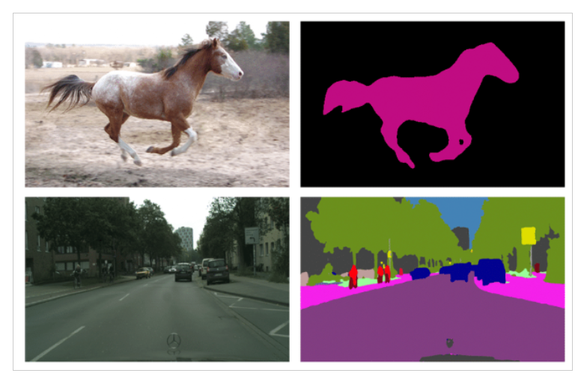

**Morphological Operations : Fill operation**

It is applied to0fill the holes in the grayscale image. A hole is nothing but area of dark pixels isolated by light pixel which represents a binary image.

FILL hole operation:

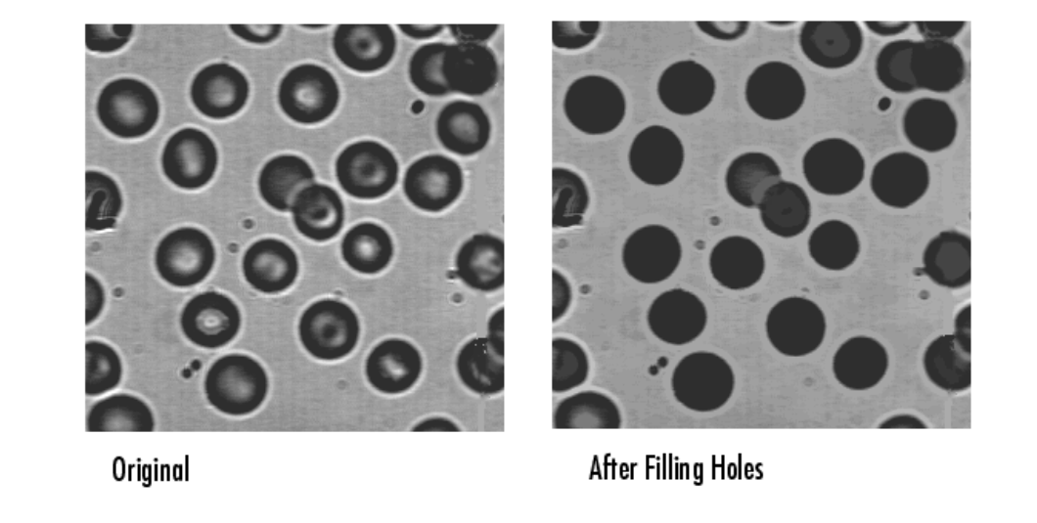

Opening Operation:

It is applied to extract the features that are smaller than the value of pixels and preserves the big amount of structure in the image to extract the objects from the input image.

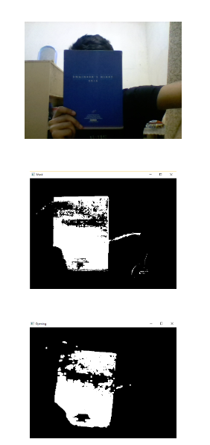

Input frame

mask

Output frame